Math Course Descriptions for Grades 1-8
1st Grade- Ten LightUnits provide 170 lessons, including quizzes and tests. Each lesson introduces one or more bite-sized new concepts. Many of the student exercises consist of continuous review to ensure that concepts stick. Students experience math as a whole rather than as isolated skills.
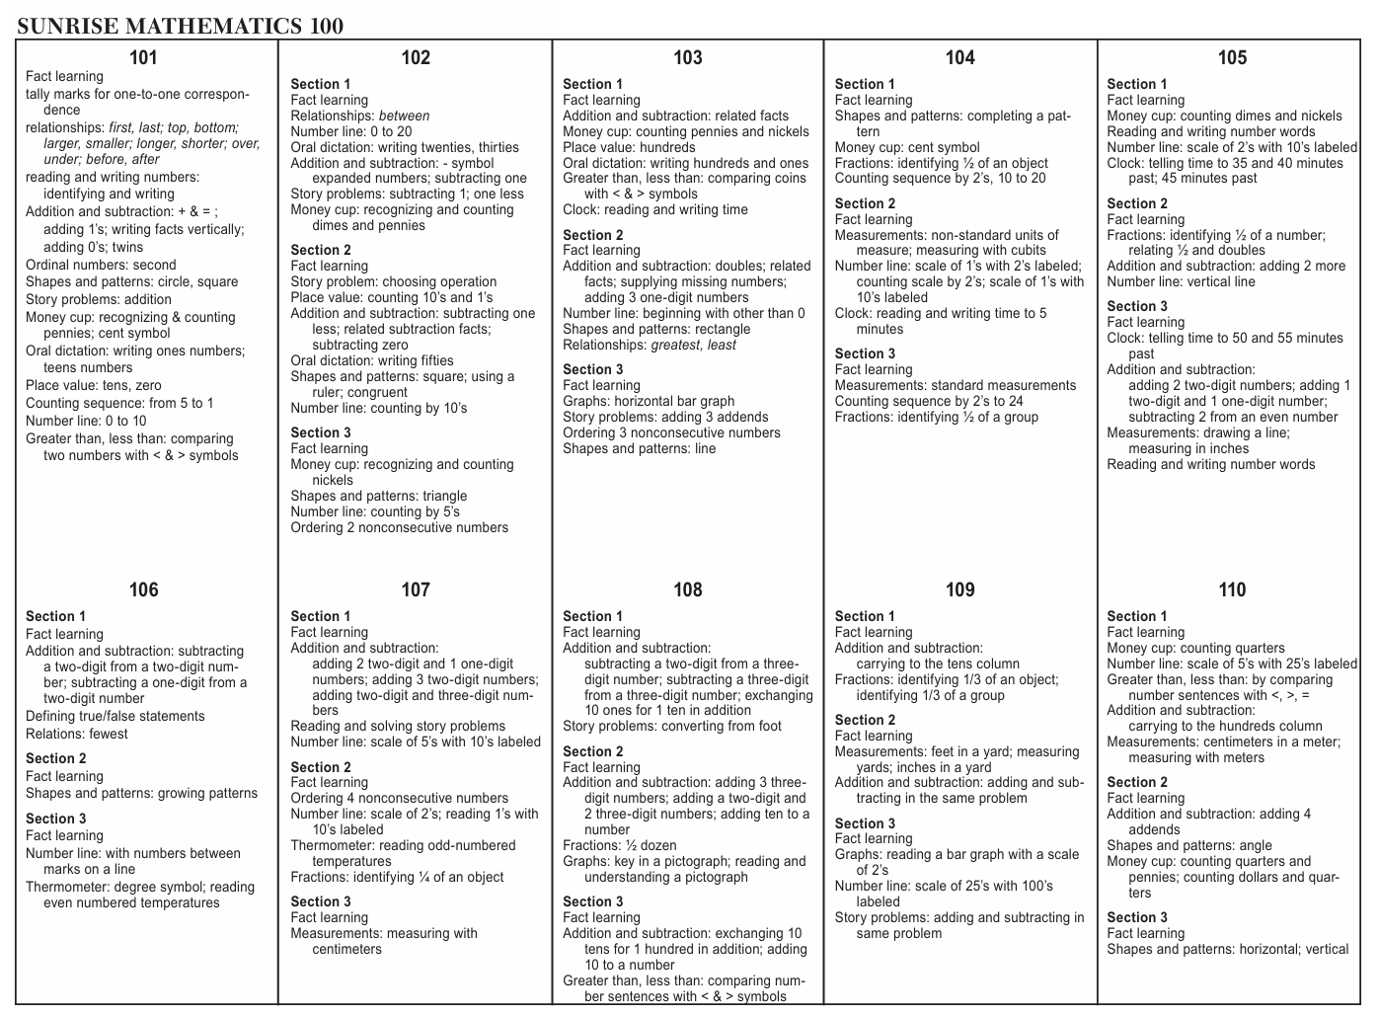
2nd Grade- Ten LightUnits provide a total of 170 lessons, including quizzes and tests. The first LightUnit in this course (LightUnit 201) reviews concepts that were taught in Math 1. This review LightUnit can also be used as a diagnostic tool to discover which concepts need more reinforcement.
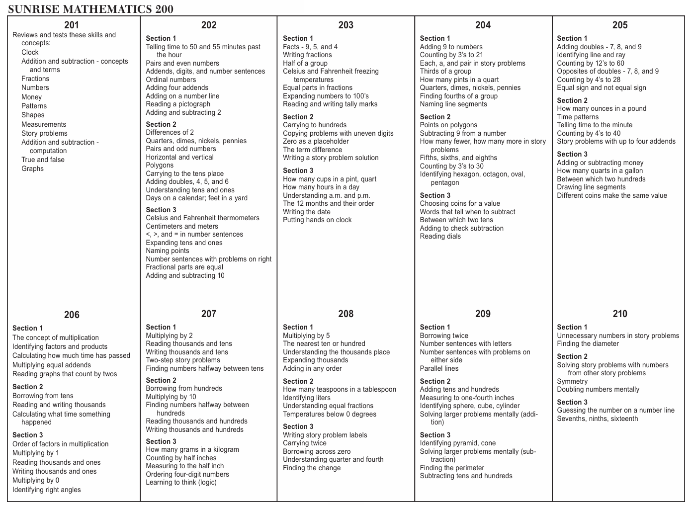
3rd Grade- Ten LightUnits provide a total of 170 lessons, including quizzes and tests. The first LightUnit in this course (LightUnit 301) reviews concepts that were taught in Math 2. This review LightUnit can also be used as a diagnostic tool to discover which concepts need more reinforcement.
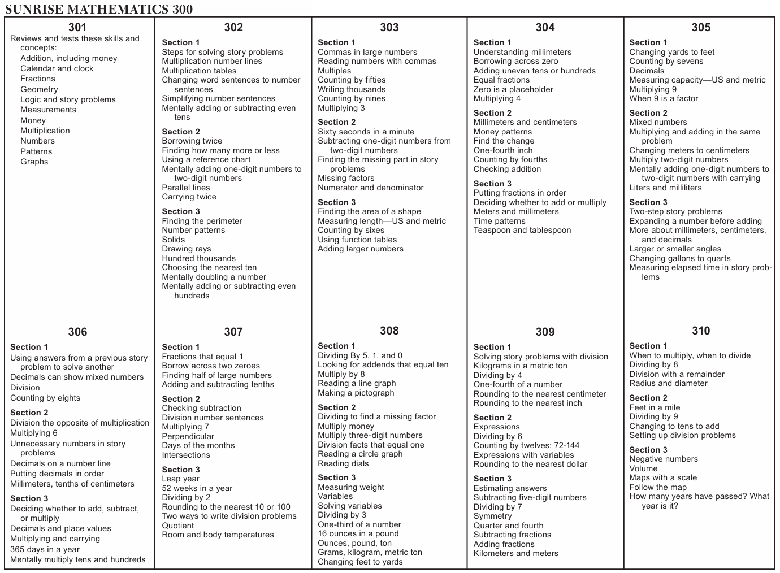
4th Grade- Ten LightUnits provide a total of 170 lessons, including quizzes and tests. The first LightUnit in this course (LightUnit 401) reviews concepts that were taught in Math 3. This review LightUnit can also be used as a diagnostic tool to discover which concepts need more reinforcement.
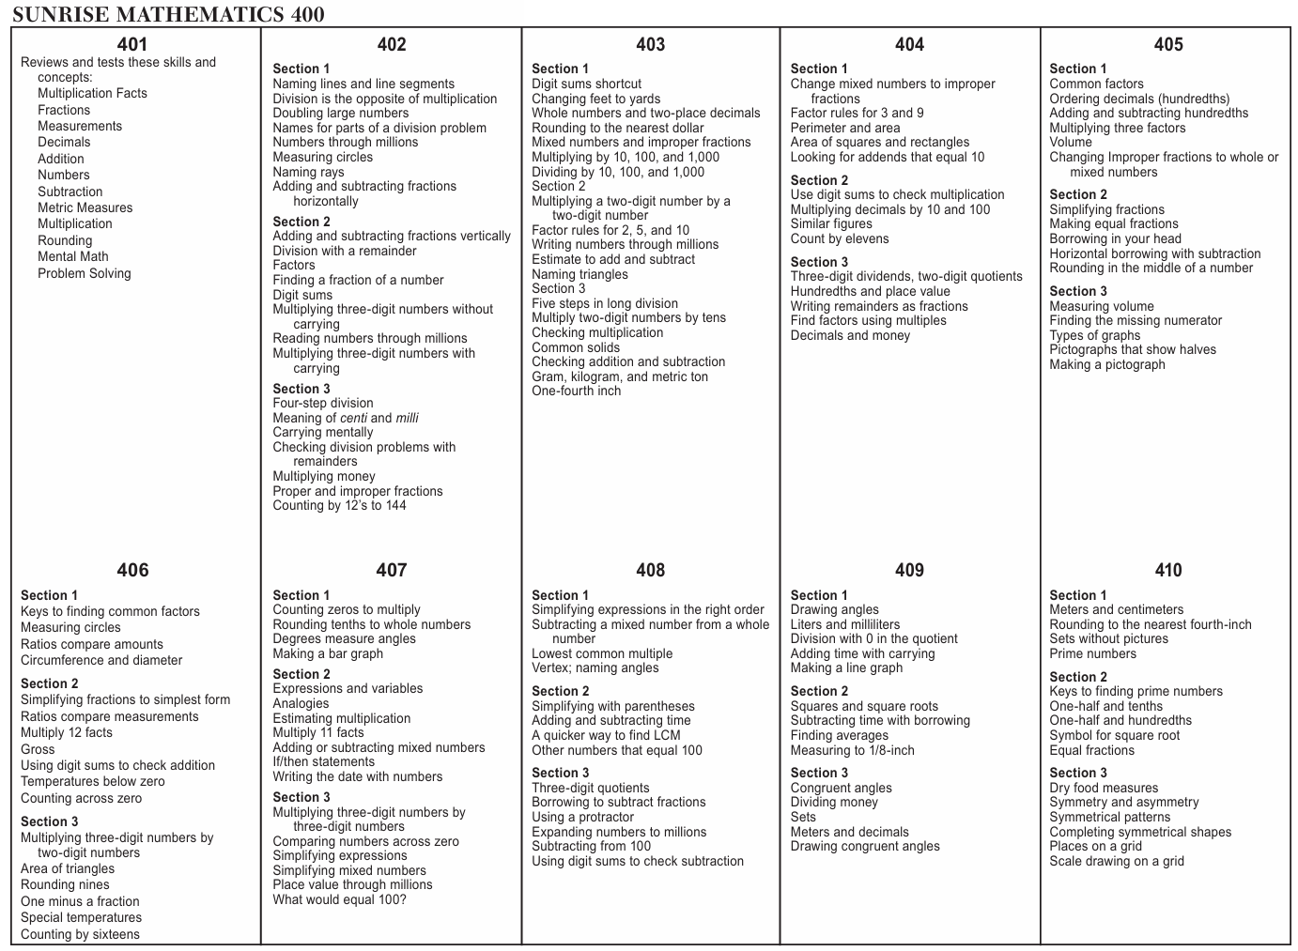
5th Grade- Ten LightUnits provide a total of 170 lessons, including quizzes and tests. The first LightUnit in this course (LightUnit 501) reviews concepts that were taught in Math 4. This review LightUnit can also be used as a diagnostic tool to discover which concepts need more reinforcement.
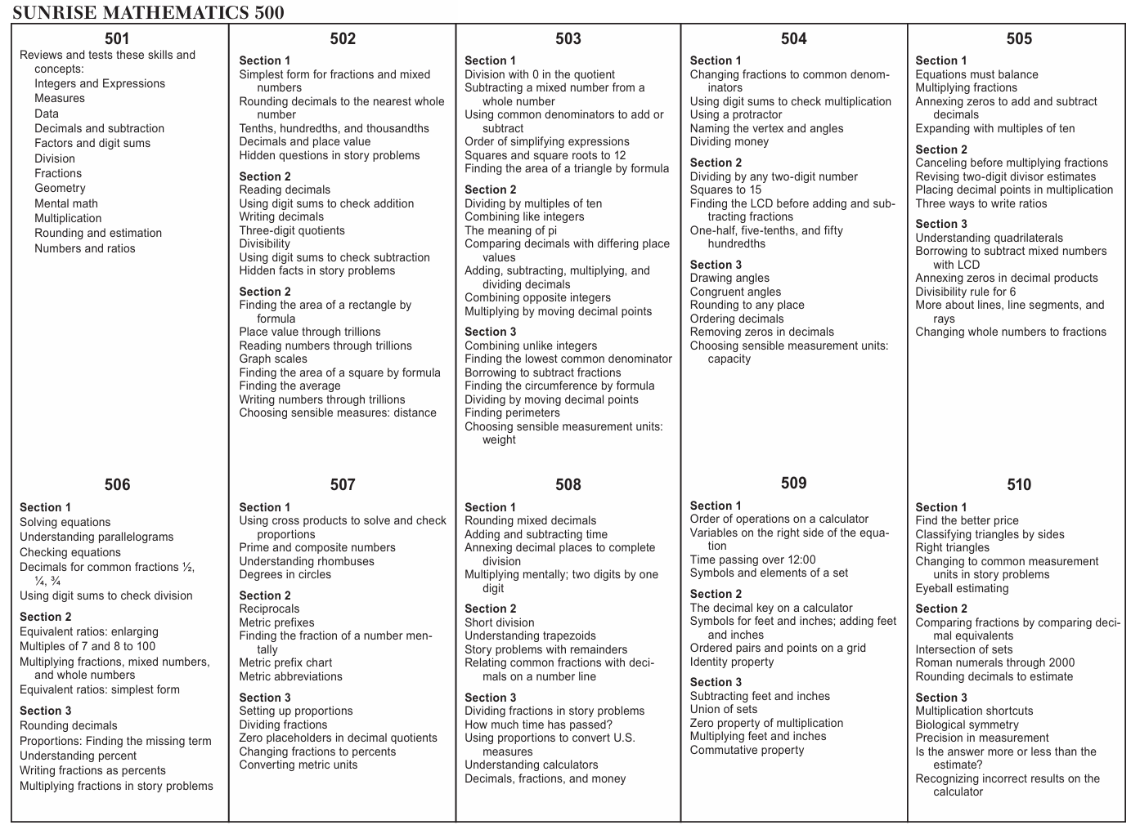
6th Grade- Ten LightUnits provide a total of 170 lessons, including quizzes and tests. The first LightUnit in this course (LightUnit 601) reviews concepts that were taught in Math 5. This review LightUnit can also be used as a diagnostic tool to discover which concepts need more reinforcement.
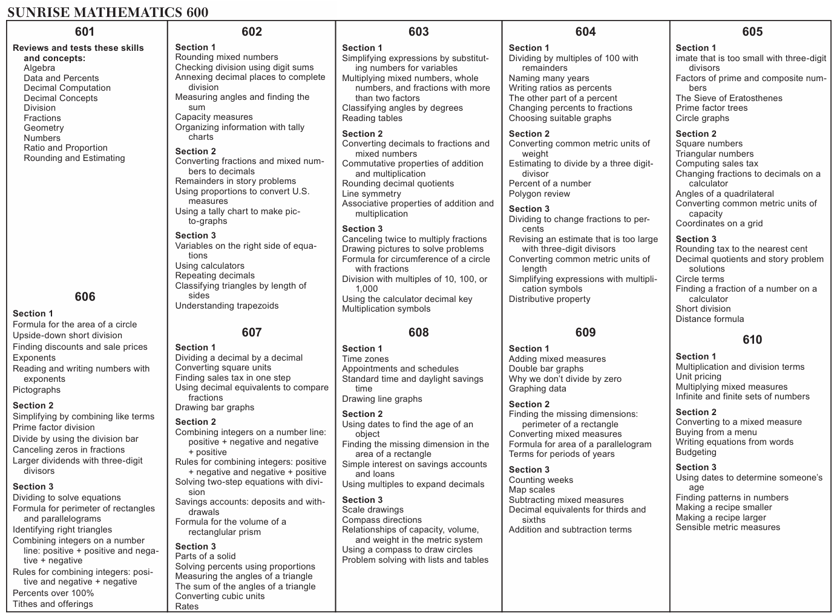
7th Grade- Ten LightUnits provide a total of 170 lessons, including quizzes and tests. The first LightUnit in this course (LightUnit 701) reviews concepts that were taught in Math 6. This review LightUnit can also be used as a diagnostic tool to discover which concepts need more reinforcement.
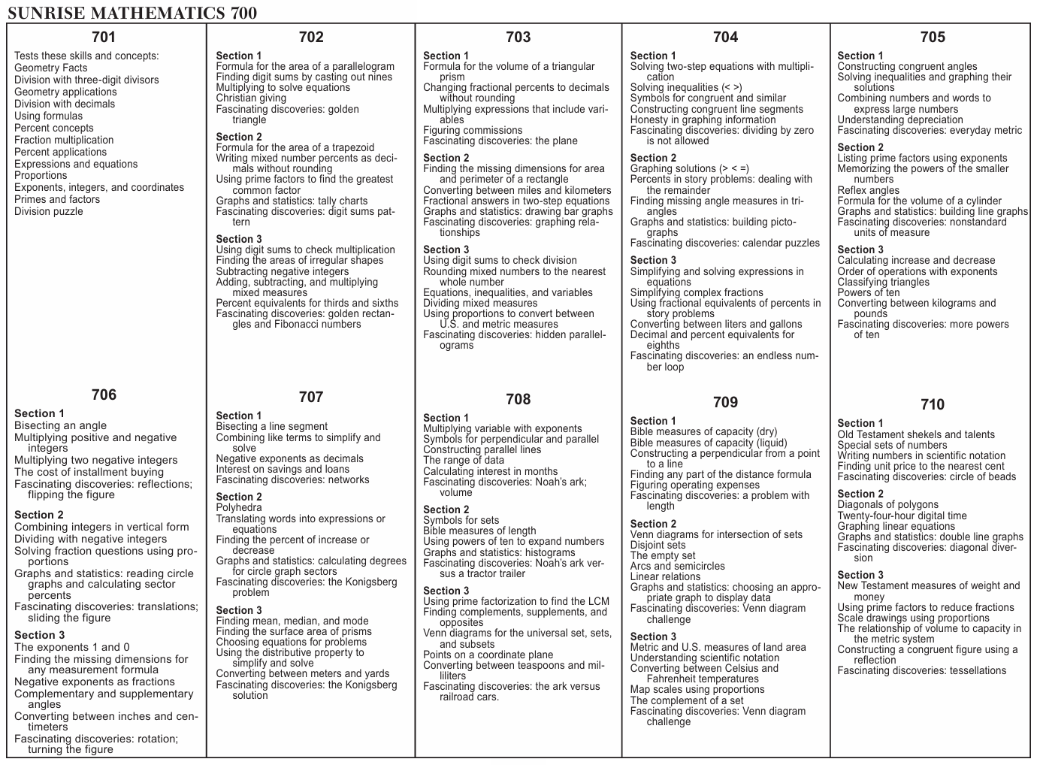
8th Grade- Ten LightUnits provide a total of 170 lessons, including quizzes and tests. The first LightUnit in this course (LightUnit 801) reviews concepts that were taught in Math 7. This review LightUnit can also be used as a diagnostic tool to discover which concepts need more reinforcement. Math 8 is suitable as a prerequisite for any Algebra I course.
